Introduction
My contest paper deals with a very difficult and challenging problem of combinatorial geometry, namely compatibility for polyiamonds.

Historical notes
Polyiamonds are less investigated than their more known “relatives” polyominoes. Solomon Golomb being postgraduate of University of Harvard (Boston, USA) delivered a report about polyominoes in 1953. With this report and following publications the history of polyominoes have begun. In difference of polyominoes consisting of equal squares the basic element of polyiamonds is equilateral triangle.
Polyiamonds are connected plane figures formed by joining unit triangles edge to edge. If polyiamond consists of n triangles it is called n-iamond.
M. Gardner noted [2] that S. Golomb had imagined (in 1954) that similarly as with polyominoes one can operated also with figures being made of unit triangles. The names, polyiamond, diamonds, triamonds, tetraiamonds, pentiamonds, hexiamonds etc.” related to pieces formed by joining equilateral triangles is due to Thomas O’Beirne (from Glasgow) [1]. The term compatibility was suggested by Andrejs Cibulis (University of Latvia). His first findings on compatibility of pentominoes were announced in the third congress of WFNMC (the World Federation of National Mathematics Competitions) in China, 1998. After then publications [6,7] on compatibility of polyominoes followed.
The problem of compatibility is not only new, but also very complicated and only some results have been found so far.
As far as it is known, the first who investigated the hexiamonds’ compatibility was Michael Reid. His findings are given in “Puzzle Fun” by Rodolfo M. Kurchan, No. 6, August 1995 [5]. However I succeeded in obtaining some improvements. Findings on compatibility of tetraiamonds and pentiamonds presented in my work are not known to have been published.
The polyiamonds divisibility properties can be studied in similar fashion to the ones of polyomino [6]. The compatibility results of tetriamonds, pentiamonds and hexiamonds have been summarized in five tables and the incompatibility was proved for some pairs of investigated polyiamonds. In the most of cases the least common multiples were found.
The findings of this work can be used for studying mathematics (in groups, circles, etc.), Olympiads, competitions and for working out new mathematics puzzles. The offered illustrations can be used also as decorative elements for fabric design and tessellations (stained glass and parquet).

Polyiamonds
Polyiamonds are connected plane figures formed by joining unit triangles edge to edge. There are a monoiamond, a diamond, a triamond, three tetraiamonds named A, I and U, four pentiamonds named I, J, P and V, and 12 hexiamonds named A, C, H, I, J, M, O, P, S, V, Y and X, respectively (Figure 1). To abbreviate the notion the following designation can be used: A-hexiamond – A₆, A-tetriamond – A₄, where the indices beside the letters show the number of the respective polyiamond’s units.
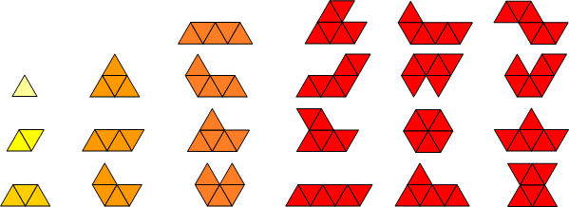
Figure 1

Properties of divisibility of polyiamonds
A polyiamond A is said to divide another polyiamond B if B may be assembled from copies of A. We also say that A is divisor of B, B is divisible by A, and B is multiple of A.
A is said to be a common divisor of two other polyominoes if it is a divisor of both. It is said to be a greatest common divisor if no other common divisor has greater area.
If two polyiamonds have a common multiple, they are said to be compatible.
A least common multiple of two compatible figures is a common multiple with minimum area. For compatible figures A and B we use the notion A ∼ B.

Some essential distinctions from natural numbers:
▲ A greatest common divisor is not necessarily unique.
For example, there are three greatest common divisors for blue 12-monds (Figure 2)
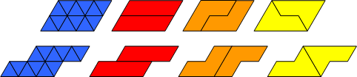
Figure 2
▲ A common multiple can not necessarily exist
In figure 3 23-mond (yellow) is not compatible with a diamond (orange). Common multiple must consist of copies of the 23-mond or of the diamond, but the three central units of 23-mond can not be divided by a diamond also in a case, if we add one more 23-mond’s copy to the first copy.
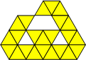
Figure 3
▲ A least common multiple is not necessarily unique
For example, a diamond (yellow) and a triamond (orange) have six different least common multiples shown in figure 4.
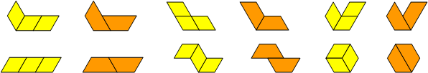
Figure 4
▲ Relation of compatibility is not transitive.
A~M and M~C does not necessarily imply that A~C. Monoiamond is trivially compatible with every polyiamond (analogously as number “1” is the divisor of every integer), but V₅ as proven further is not compatible with X₆
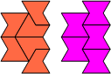
V₅ ~ P₅, P₅ ~ X₆,
- Algorithm for determining common multiple of two polyiamonds is not known; problem of compatibility is very difficult and has been solved only in rather a few cases.

Compatibility Determining Methods Used
Although compatibility in fact is investigated for every pair separately, some methods to facilitate the investigation are offered. All methods are based on the variations of two polyiamonds’ covering.

Parallelogram’s method
The essence: to assemble a parallelogram of investigated pair both polyiamonds’ two or more copies and to search a common multiple as a respective parallelogram.

Method of detection a least common multiple
If the less polyiamond A can be drawn inside the greater polyiamond B and from uncovered units of B the polyiamond A can be assembled, then a least common multiple can be found.
For instance: A least common multiple of V₅ and U₄ will contain 20 units. V₅ and U₄ can be covered as it is shown in figure 5. Exactly one unit of V₅ remains uncovered. By making three more copies of the acquired covering and assembling the uncovered units as it is shown in figure 6 a least common
multiple of V₅ and U₄ is got.
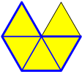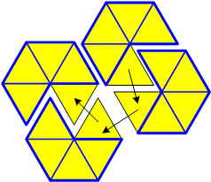
Figure 5 Figure 6

Plus – minus method
The essence: to get the “well-balanced” covering. It can be got then by covering polyiamond A with polyiamond B the number of uncovered A units is equal with the number of B units, which are out of the polyiamond A. By assembling plus units with minus units a common multiple of investigated polyiamond’s pair can be found.
For instance: I₅ and J₅ can be covered so, that one of the I₅ units remains uncovered (“+”) and one of the J₅ units - unused (“–”) as it shown below (Figure 7). It can be made one more copy of the acquired covering and by assembling plus units with minus units a least common multiple of I₅ and J₅ is found
(Figure 8).
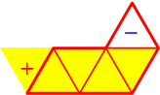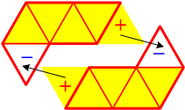
Figure 7 Figure 8

The Essence of Summarizing Results
The basic information about the compatibility of investigated polyiamonds is summarized in tables. The respective cell is filled with the number of the examined pair greatest polyiamond’s copies used for compatibility proving illustration (common multiple). If there is a proof for incompatibility, then the respective cell of the table is filled with a dash. If the compatibility is not found and there is no proof for incompatibility then the respective cell is remained free. The compatibility results of investigated polyiamonds are summarized in five tables (numbers in green stand for the findings of A.Cibulis)

Improvements of Michael Reids’ Compatibility Table of Hexiamonds [5]
The incompatibility is proved for an O- and A-hexiamond and an O- and X-hexiamond. Michael Reid have offered the common multiple (Figure 9) of S- and Y-hexiamond consisting of six hexiamond copies. However, I have succeeded in finding the smaller multiple, namely the one consisting of four copies (Figure 10).

Figure 9 Figure 10

Incompatibility of Tetraiamonds, Pentiamonds and Hexiamonds
To prove the incompatibility of polyiamonds I have used a “borderline” method. If two polyiamonds were compatible, then their common multiple could border with any straight line and could be placed above this straight line without exceeding it. Since a common multiple of polyiamonds A and B can be made of copies A or B, then at least one copy of A or B could border with a straight line and would not exceed it.
Explanations for the figures following below:
¹ In figure 11-17 the triangles marked red can not be covered with O-hexiamond because we can make covering only above the straight line without exceeding it (common multiple can be limited with any straight line). So the red triangles may not be covered with any of the considered pair’s polyiamond.
² In figure 18-33 the triangles marked red can not be covered with X-hexiamond because we can make covering only above the straight line without exceeding it. So the red triangles may not be covered also with any of the considered pair’s polyiamond, too. As there are two cases how X-hexiamond can border with a straight line (figure 14 and 15) by proving the incompatibility of a pair the both cases must be considered.

The Incompatibility of O-hexiamond and A-tetraiamond
Proof. Let’s assume that O-hexiamond and A-tetraiamond has a common multiple and it is above a line and at least one its O-hexiamond borders with this line. Let’s see over the O-hexiamond’s triangle M (Figure 11), which’s edge borders with this straight line. M can be covered with A-tetraiamond only in two cases (we do covering only above the straight line), but in both cases the red triangles will be covered (Figure 12 and 13). Since none of the red triangles may be covered (view ¹), then we may conclude, that considered polyiamonds are incompatible.

Figure 11 Figure 12 Figure 13

The Incompatibility of O-hexiamond and X-hexiamond
Proof. Let’s assume that O-hexiamond and X-hexiamond has a common multiple and it can be put above a line so, that at least one its O-hexiamond borders with this line. Let’s see over the O-hexiamond’s triangle M, which’s edge borders with a line (Figure 15). M can be covered with X-hexiamond only in two cases. In both cases the red triangles will be covered (Figure 14 and 15). Since none of the red triangles may be covered (view ¹), we may conclude, that considered polyiamonds are incompatible.

Figure 14 Figure 15

The Incompatibility of O-hexiamond and A-hexiamond
Proof. Analogous to the cases above, let’s see over the O-hexiamond’s triangle M. It may be covered with A-hexiamond only in two cases (Figure 16). But by covering O-hexiamond’s triangle T we will cover also red triangles (Figure 17). Since the red triangles may not be covered (view ¹), then it may be concluded, that these polyiamonds are incompatible.
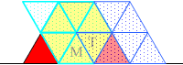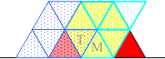
Figure 16 Figure 17

The Incompatibility of X-hexiamond and V-pentiamond
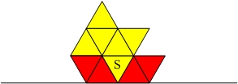
Figure 18 Figure 19
Proof. 1. X-hexiamond and V-pentiamond have a common multiple and at least one of its X-hexiamond borders with a line as it is shown in figure 18. In this case X-hexiamond’s triangle S can be covered with V-pentiamond as it is shown in figure 20 and 21. In both cases the red triangles are covered. Since the red triangles may not be covered (view ²), then the common multiple doesn’t exist, which’s at least one X-hexiamond borders with a line as it is shown in figure 18.
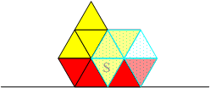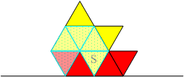
Figure 20 Figure 21
Then a common multiple’s at least one X-hexiamond coould border with a line as it is shown in figure 19. The triangle H of the X-hexiamond can be covered with V-pentiamond in two cases. In both cases we get the triangle J, which can not be covered with V-pentiamond without covering red triangles (Figure 22 and 23). Since red triangles may not be covered (view ²) the examined polyiamonds are incompatible.
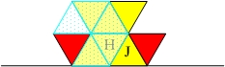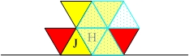
Figure 22 Figure 23

The Incompatibility of X-hexiamond and A-tetraiamond
Analogous to the case above the examined polyiamonds common multiple’s (if it exists) X-hexiamond can border with a line in two cases as it is shown figure 18 and 19 above. The red triangles may not be covered (view ²).
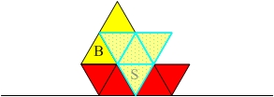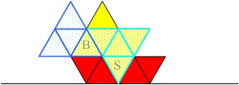
Figure 24 Figure 25
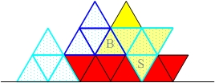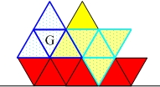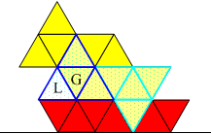
Figure 26 Figure 27 Figure 28
X-hexiamonds’ triangle S can be covered with A-tetraiamond as it is shown in figure 28. In this case we get triangle B, which can be covered with A-tetraiamond as follows in figure 25. The next A-tetraiamond can be added as it is shown in figure 26, let’s mark red the units, which are impossible to cover with A-tetraiamond, so we can not cover them also with X-hexiamond. Now let’s see how the A-tetraiamonds’ triangle G can be covered with X-hexiamond (Figure 27). It can be made only in one case, but in this way we will get the A-tetraiamonds’ triangle L (Figure 28), which could not be covered with X-hexiamond without covering red triangles. So we can conclude that there is no such a common multiple, which’s at least one X-hexiamond borders with a line as it is shown in figure 18.
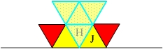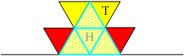
Figure 29 Figure 30
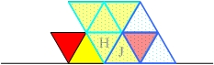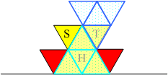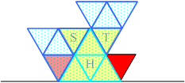
Figure 31 Figure 32 Figure 33
Then it is possible that a common multiple’s X-hexiamond can border with a line as it is shown in figure 19. Its triangle H can be covered with A-tetraiamond in two cases (figure 29 and 30). In figure 29 the triangle J can not be covered with A-tetraiamond without covering red triangles, since red triangles may not be covered this case is not valid. Then let’s see the triangle T in figure 30. It can be covered with A-tetraiamond only in one case without covering the red triangle (Figure 32). By covering the triangle S (figure 33) with A-tetraiamond the red triangles will be covered, too. Since red triangles can not be covered the examined polyiamonds are incompatible.

